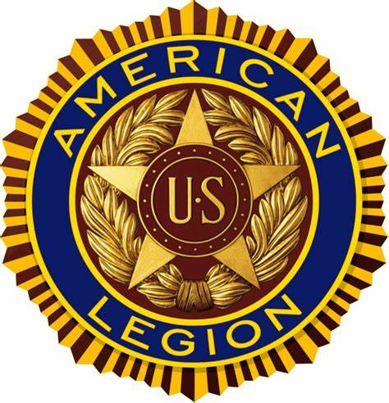

The American Legion
Department of Colorado
2026 Convention Agenda
June 19, 2026-June 20, 2026
American Legion Post #113 Alamosa, Colorado

Thursday June 18, 2026
4:00 - 600 pm Preconvention DEC Meeting
6:00 – 7:00 pm Dinner – Hamburger and Hot Dogs
7:00 pm Committee Meetings - Resolutions, Constitution and By-Laws,
Apportionment, Rules, and Order, Credentials Need help with this
Friday, June 19, 2026
8:00am Registration opens- Alamosa Post #113
9:00am Joint Opening Ceremony-
Commander- Mike Crow
ALA President – Shelley McLatchie
SAL Commander- Rob Barry
ALR State Chairman –
Call for Advancement of Colors- American Legion Post ???
National Anthem - Kaye Kerr
Invocation - Chaplain
Pledge Allegiance – ALR
POW/MIA Empty Chair Ceremony – Sgt at Arms – Jon Anders
Preamble –
Military Child Table – ALA Jr Auxiliary

9:10am Introduction of American Legion Officers- Commander Mike Crow
Sr. Vice Commander-
Jr. Vice Commander-
Finance Officer-
Chaplain- Rev
Historian-
Sgt-At-Arms-
Asst. Sgt- At- Arms –
Asst. Sgt- At- Arms –
NEC- Tom Florez:
ANEC- Greg Jackson
Introduction of Dept. Staff
Department Adjutant- Jim Talaska
Dept. Veterans Service Officer Will Davis
DSO Admin Joan St. Marie
Introduction of Past Department Commanders - Commander Johnson Charles “Pat” Smith; Tom Bock; Ed Wearing; Doug Wooddell; Ralph Bozella; Raymond” Tim” Grabin; Frank McCurdy; James Gates; Carol Kennedy; Richard Humphrey; Tom Florez; John “Jay” Bowen; Terri Clinton; Rob D Smith; Gregory Jackson;
Past Dept Adjutant Pat Smith
Past National Commander Tom Bock
Introduction of National Officers and National Staff
Chairman Charter Restoration Committee – PNC Paul Dillard
PNC Dave Rehbien
PNC Jimmy Foster
National Judge Advocate Mark Seavey
Ken George

Introduction of ALA Officers - Presidents
Introduction of SAL Officers – SAL Commander
Introduction of ALR Officers – ALR State Chairman
9:20am Introductions of guests/greetings- Commander
Presentation of Eagle Scout of the Year to by
10:00am Call of Order- Commander
Reading of Convention Call- Department Adjutant
Rules and Order Report-
Reading of Credentials Report
Report of Officers and Committees
Department Commander Report –
Jr, Vice Commanders Report of Districts –
NEC Report and VA&R- Tom Flores
Finance Officer Report – Mark Kilstrom

12:00pm NOON Lunch: Tacos rice and beans
1:30pm Auxiliary session
1:30pm SAL Session
1:30 pm UVC military and veteran advocacy
1:45pm American Legion Programs Committee Reports
Americanism;
Baseball – Dave Baker
Boy Scouts- Steve Hayes
Boys State- Deb Davis or Norm Steen
Children and Youth – Tina Kyprios
Community Service - Richard Devlin;
Jr Shooting - Larry Underwood;
Legion Riders - Steve Hayes;
Legislative - Jim Stanko;
National Security – Steve Butner
Oratorical – Tina Kyprios
POW/MIA -
2:30pm NJA Seavey on per capita increase. Motion and adoption
3:00pm
4:30pm Benediction- Department Chaplain
6:00pm Dinner
6:00pm-9:00pm Hospitality Room

Saturday June 20, 2026
8:00am Delegate Registration – Pick up Membership Cards
8:30am Family Memorial Service
Pastor
9:00am Reconvene: Commander Crow
Reports.
Resolution Committee Report-
Constitution and By-Laws Report
2nd Reading of Credentials Report –
10:00am Convention Site Selection Committee Report – Steve Butner
10:15am Introductions of Department Oratorical Winner
By Oratorical Chair Tina Kyprios
10:30am Commander’s Awards
Legionnaire of the Year
Special Award & Recognition
11:00am Reading of Resolutions
12:00pm Past Commanders Lunch Pulled Pork
1:30pm Reconvene - Commander Mike Crow
Final Report of Credentials Committee –
Voting on Resolutions
District Caucuses- Elect National Convention Delegates
Ratification of Delegates & Alternates to National Convention
Good of the Legion
Announcements
Benediction- Department Chaplain
3:30pm Post Department Executive Committee Meeting-
DEC Pick up District Membership Cards & District Awards

4:00pm Riders Meeting- ???? Room
6:30pm Cocktail Reception- Cash Bar-
7:00pm Testimonial Banquet- Roast beef, potato
Commander
ALA President
SAL Commander
ALR Steve Hayes
POW/MIA Remembrance Service- Post Honor Guard-
Membership Report/Awards -

