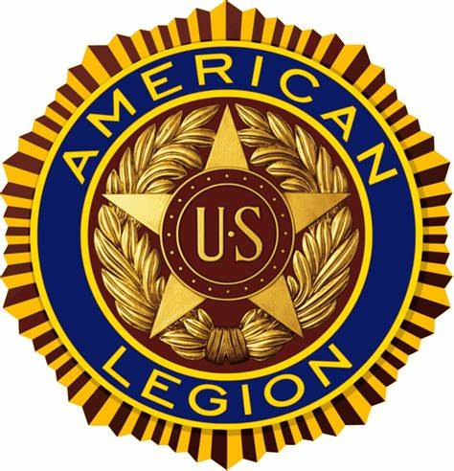

The American Legion
Department of Colorado
2026 Mid-Year Conference Agenda
January 23-24, 2026
American Legion Posts #38 - 209, Colorado Springs, Colorado

Friday January 23, 2026
4pm DEC meeting Post #209
6pm Dinner at Post #209

Saturday, January 24, 2026 Post #38
9:00am Joint Opening Ceremony-
Commander- Mike Crow
ALA President – Shellie McLatchie
SAL Commander- Rob Barry
ALR State Chairman – Steve Hayes
Call for Advancement of Colors- American Legion Post ???
Invocation - Chaplain Pastor Stan Hamamoto
Pledge Allegiance – ALR Steeve Hayes
POW/MIA Empty Chair Ceremony – Sgt at Arms – Jon Anders
Preamble – Department Sr. Vice Commander Sarah Tobin
Military Child Table – ALA Jr Auxiliary
9:10am Introduction of American Legion Officers- Commander Mike Crow
Sr. Vice Commander- Sarah Tobin,
Jr. Vice Commander- Tina Kyprios, Michael Bosshardt, George Horgan, George Apadoca, Anthony Koch, Adam Valdez,
Finance Officer- Mark Kilstrom
(Asst. Finance) Mike Gott
Chaplain- Pastor Stan Hamamoto
Sgt-At-Arms-Jon Anders;
NEC- Tom Florez:
ANEC- Greg Jackson,
Introduction of Dept. Staff
National Staffer: Jim Talaska
Dept. Service Officer Will Davis
DSO Admin Joan St. Marie
Introduction of Past Department Commanders - Commander Crow
Introduction of ALA Officers – President Shellie McLatchie
Introduction of SAL Officers – SAL Commander Rob Barry
Introduction of ALR Officers – ALR State Chairman Steve Hayes
9:20am Introductions of guests/greetings- Commander Crow
9:45am Resolutions training by PDC Ralph Bozella
11:00am Discussion of items from the DEC meeting
The ALA will be excused to go to Post #209 to commence at 10:30hrs
12:00pm NOON Lunch: Taco Bar at Post #38 $10.00 per person please RSVP to: John C Langley clangley30@yahoo.com (903)292-9341
PDCC’s meeting and lunch at Post #38
1:30pm American Legion Programs Committee Reports
Americanism
Baseball – Dave Baker
Boy Scouts- Steve Hayes
Boys State- Deb Davis or Norm Steen
Children and Youth – Tina Kyprios
Community Service -
Legion Riders - Steve Hayes
Legislative - Jim Stanko
National Security – Steve Butner
Oratorical – Tina Kyprios
POW/MIA -
2:00pm LEO/FF award presentation
4:20pm Benediction- Department Chaplain
4:30am Adjourn
6:00pm Dinner at Post #209
7:00pm-9:00pm Hospitality Room
Notes:
Meal pre-purchase for 2026 Department of Colorado Mid-Year convention Meals served at Neal Thomas Jr. Centennial Post 209, 3613 Jeannine Drive, Colorado Springs, CO 80917. There are three meals that can be purchased at Post 209 during Mid-Year: - Friday January 23rd, 6pm: Spaghetti, Chicken Fettuccini Alfredo, Garlic Bread, Salad, Dessert: $10 - Saturday January 24th 12pm: Build your own deli style sub sandwiches, chips, soup, lemonade, iced tea, coffee: $10 - Saturday January 24th 6pm: Chicken Fried Chicken, Mashed Potatoes, white gravy, veggies, rolls, salad, dessert, lemonade, iced tea, coffee: $15 Register and pre-pay at this link: https://www.zeffy.com/en-US/ticketing/2026-department-of-colorado-mid-year-meals-post--209 To pre-pay, select your desired meals, then process payment for total in the form. Additional notes: - - To RSVP and pay on site instead of pre-pay, email Jackie Bowen at jackiebowen2005@yahoo.com or contact by phone text to 901-481-0673. Include your name, Post/unit/squadron, email or phone, "mid-year meal" and 23 Jan dinner, 24 Jan lunch, and/or 24 Jan dinner in your RSVP. DO NOT submit an RSVP if you pre-pay. Pre-Pay and RSVPs must be received NO LATER THAN Noon 21 January. - - - Walk-in's can only be served after Pre-Pay and RSVPs have been served and only if food is still available. Max capacity each meal is 150 people. The pre-pay option for each meal will be taken down once it reaches the limit. Pre-Pay will receive an email ticket for the meal. Print the tickets and bring the ticket with you when you arrive for each meal.
NOTE: The TAL/SAL lunch will be at Post #38 on Saturday at noon please RSVP to:
Lunch: Taco Bar at Post #38 $10.00 per person please RSVP to: John C Langley clangley30@yahoo.com (903)292-9341
The DEC meeting will take place on January 23rd 2026 at 16:00 hrs at Post #209 and will recess and reconvene after the adjournment of the Mid-Year Conference and proceed until all business is concluded.
The addresses to the Hotel and Posts are as follows:
Neal Thomas Jr. Centennial Post 209, 3613 Jeannine Drive, Colorado Springs, CO 80917. Phone: (719) 599-8624
American Legion Post 38 6685 Southmoor Dr, Fountain, CO 80817
Phone: (719) 392-9901

Tru by Hilton Colorado Springs Airport Address: 2845 Zeppelin Rd Suite B, Colorado Springs, CO 80916. If you call the hotel and ask for the Legion rate it will be at $80.00 for a normal room and $90.00 for a suite.
Phone: (719) 418-0000

